**Document Type: QA Test Result**

Report Name: **9C_C_02 Item Opening Stock Report**

Tester Name: Md. Amin Khan

Test Date: 05-12-2023

**In UI:**

1. Stock Date is showing with Time, It should show only date with corrected format. Format: dd-mm-yyyy [**Global Format**]
2. Add “Amount(BDT) after Rate column

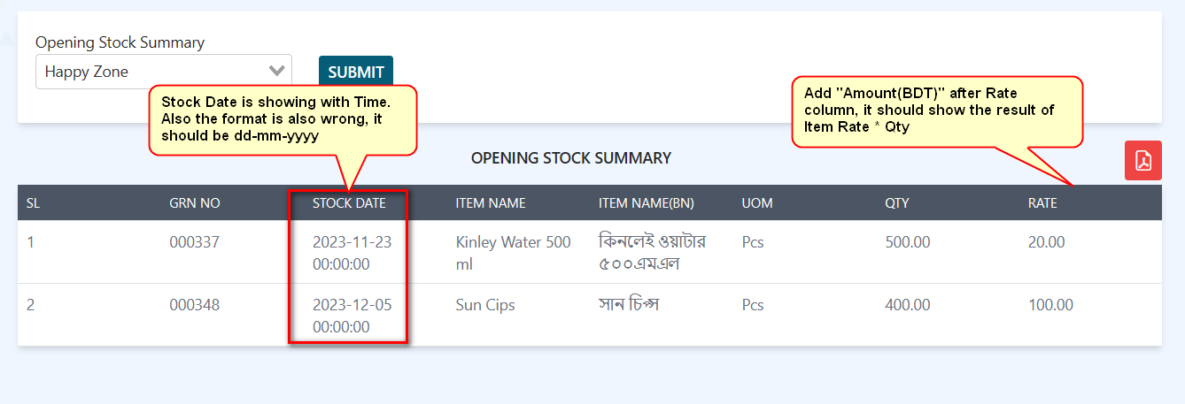

**In PDF:**

1. Stock Date is showing in wrong format. The Format should be: dd-mm-yyyy

